Computer Vision Homework 5

Name: 黃新予

Student ID: f08922136

1. **Environment Setup  
   Language: Python 3 (on VS code)  
   Library: numpy, PIL**
2. **Q1: Gray scale dilation**step 1: open lena.bmp as original image  
   step 2: create a new image as output image  
   step 3: traverse all pixels in original image. Overlap kernel on each pixel. Find the **maximum** value in the range that kernel value = 1.   
   step 4: Because K(x) = 0, we use local maximum as new pixel and set new pixel value to output image.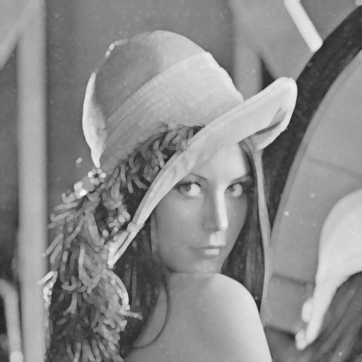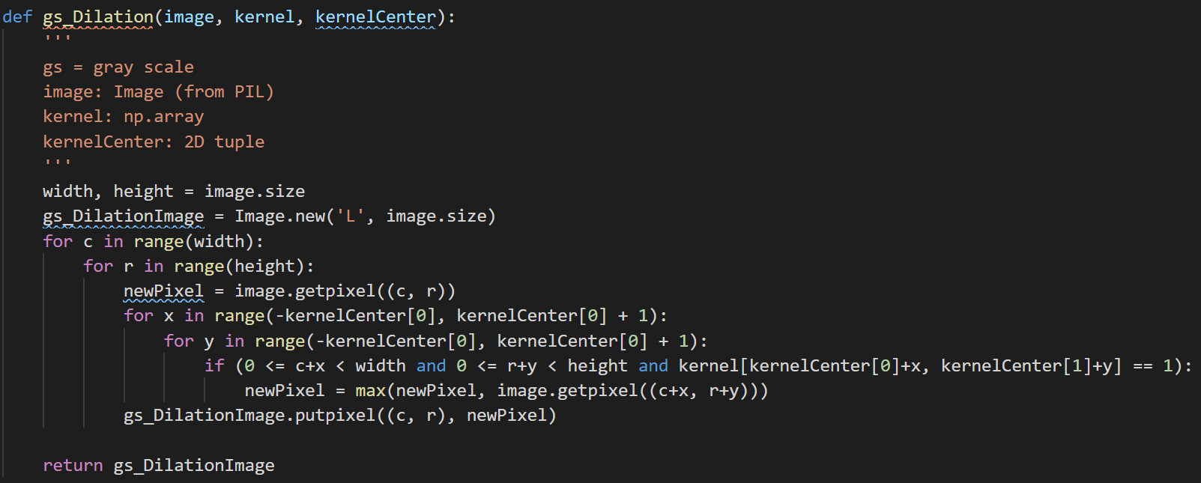
3. **Q2: Gray scale erosion**step 1: open lena.bmp as original image  
   step 2: create a new image as output image  
   step 3: traverse all pixels in original image. Overlap kernel on each pixel. Find the **minimum** value in the range that kernel value = 1.   
   step 4: Because K(x) = 0, we use local minimum as new pixel and set new pixel value to output image.  
   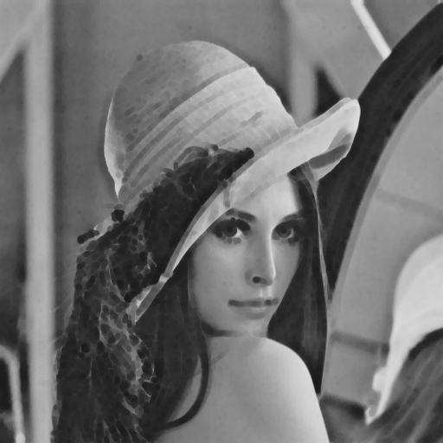  
   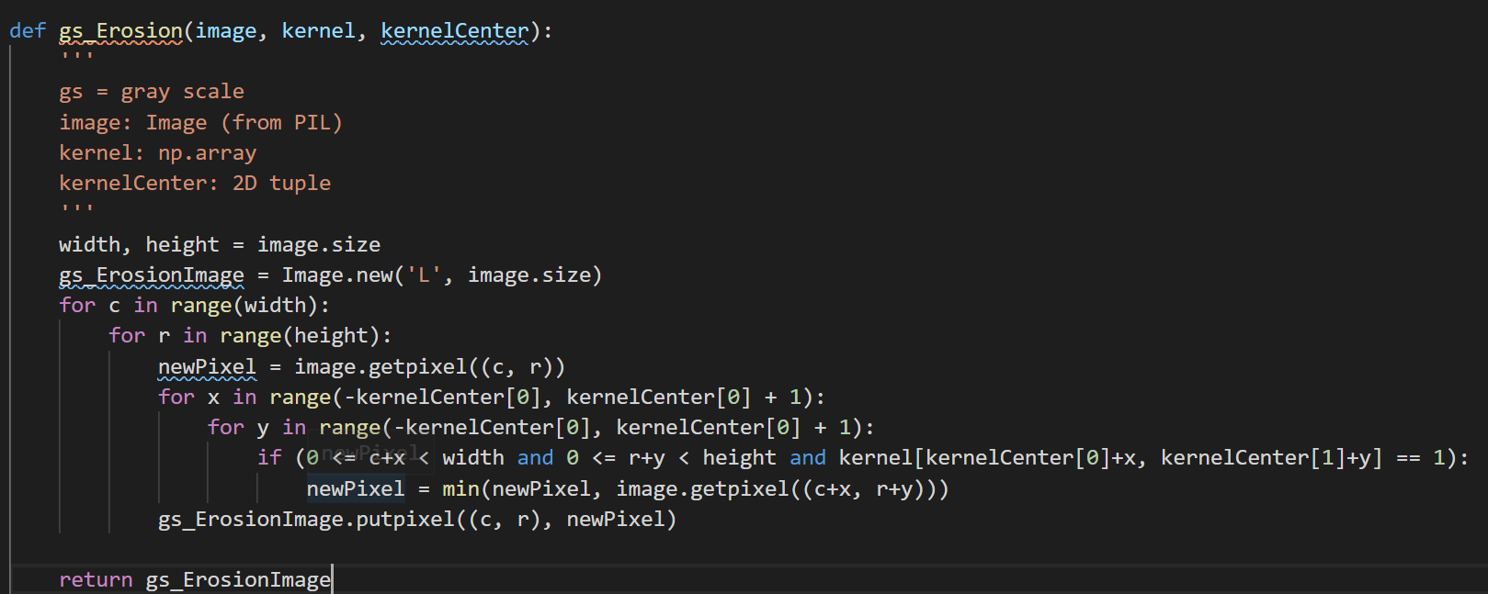
4. **Q3: Gray scale opening**step 1: call function gs_erosion first, then call function gs_dilation  
   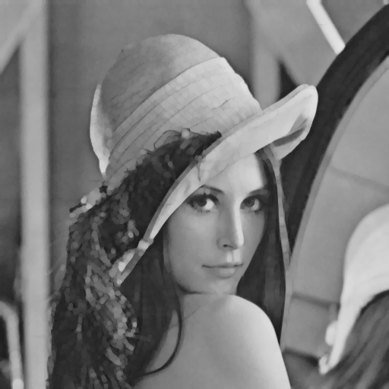  
   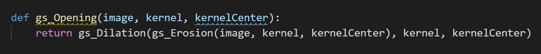
5. **Q4: Gray scale closing**step 1: call function gs_dilation first, then call function gs_ erosion  
   